

Web-Based Music School Manager

Project Plan

Author: Aaron Redmond

Student ID: C00002396

Supervisor: Paul Barry

Contents

Introduction 4

Project requirements 4

Hardware 4

Software 4

Gantt chart 5

Project Breakdown 6

1. Choose Technologies 6

1.1 Choose Framework 6

1.2 Choose Database 6

2. Design Manual 6

3. Web Page 6

4. Phase 1 – Set up 7

4.1 Code 7

4.2 Test 7

Milestone 1 7

5. Phase 2 – Admin 7

5.1 Code 7

5.2 Test 7

5.3 Integrate 8

Milestone 2 8

6. Phase 3 – Teacher 8

6.1 Code 8

6.2 Test 8

6.3 Integrate 8

Milestone 3 8

7 Phase 4 – Student 9

7.1 Code 9

7.2 Test 9

7.3 Integrate 9

Milestone 4 9

8. User Manual 9

9. Project Report 10

10. Code Listing 10

# Introduction

This document contains the project plan for the Web-Based Music School Manager. It contains the breakdown of my project from start to completion. Starting on Monday the 20th of December 2010 and finishing on Friday 8th of April 2011.

The project plan contains timeslots for documentation and research as well as the breakdown of the development into four distinct phases:

1. Phase 1
   1. Set up
2. Phase 2
   1. Admin
3. Phase 3
   1. Teacher
4. Phase 4
   1. Student

There is a milestone at the end of each phase, where we should have a working version of the application containing the functionality developed in the previous phase.

# Project requirements

As this is a web based application, the project requirements are minimal. The hardware and software requirements for this project are as follows.

## Hardware

The only hardware requirement for this project is a development environment. This project will be mainly developed on my assigned college PC, with additional work being done on my personal PC and laptop.

## Software

The software requirements for this project are:

* Application framework
* Database

Both of which will be open source software.

# Gantt chart

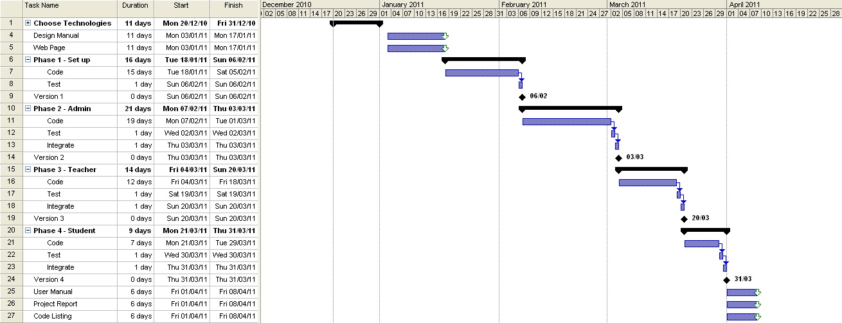

Figure : Gantt chart

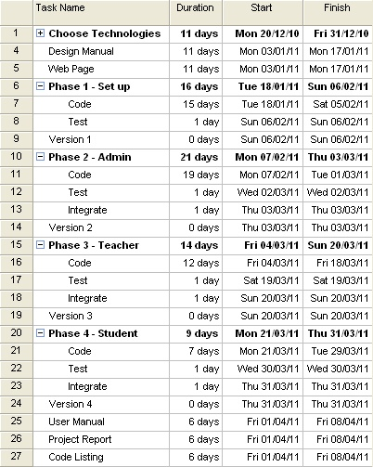

Figure : Tasks

# Project Breakdown

In the following section I will give a brief description of each task and list the duration, start date and end date of each task.

## Choose Technologies

* Duration: 11 days
* From: Mon 20/12/10
* To: Friday 31/12/10

Before development of any kind can start, the technologies which will be used to build the application must be chosen.

### 1.1 Choose Framework

* Duration: 5 days
* From: Mon 20/12/10
* To: Friday 24/12/10

I must decide on which framework I will use for my project. This choice is very important as it will be the backbone of my application.

### 1.2 Choose Database

* Duration: 5 days
* From: Mon 27/12/10
* To: Friday 31/12/10

A database must also be chosen. There are many good open source databases to choose from and one must be chosen which integrates well with the chosen framework.

## Design Manual

* Duration: 11 days
* From: Mon 03/01/11
* To: Mon 17/01/11

This is the design manual for the project and it should model the application design and describe how it should be used.

## Web Page

* Duration: 11 days
* From: Mon 03/01/11
* To: Mon 17/01/11

A simple web page must be created, which describes the project and contains links to all project documentation created so far.

## Phase 1 – Set up

* Duration: 16 days
* From: Tue 18/01/11
* To: Sun 06/02/11

This is the initial development phase where the project development starts.

### 4.1 Code

* Duration: 15 days
* From: Tue 18/01/11
* To: Sat 05/02/11

Develop the frame of the application.

### 4.2 Test

* Duration: 1 days
* From: Sun 06/02/11
* To: Sun 06/02/11

Test the code written in the previous step.

## Milestone 1

* When: Sun 06/02/11

At this stage we should have the basic structure of the application.

## Phase 2 – Admin

* Duration: 21 days
* From: Mon 07/02/11
* To: Thur 03/03/11

In this phase the administration section of the application will be developed.

### 5.1 Code

* Duration: 19 days
* From: Mon 07/02/11
* To: Tue 01/03/11

Code the admin section.

### 5.2 Test

* Duration: 1 days
* From: Wed 02/01/11
* To: Wed 02/01/11

Test the admin section.

### 5.3 Integrate

* Duration: 1 days
* From: Thur 03/01/11
* To: Thur 03/01/11

Integrate the admin code with the code developed in phase 1.

## Milestone 2

* When: Thur 03/01/11

At this stage we should have a working administrator section.

## Phase 3 – Teacher

* Duration: 14 days
* From: Fri 04/03/11
* To: Sun 20/03/11

In this phase the teacher section of the application will be developed.

### 6.1 Code

* Duration: 12 days
* From: Fri 04/03/11
* To: Fri 18/03/11

Develop the teacher section.

### 6.2 Test

* Duration: 1 days
* From: Sat 19/03/11
* To: Sat 19/03/11

Test the teacher section.

### 6.3 Integrate

* Duration: 1 days
* From: Sun 20/03/11
* To: Sun 20/03/11

Integrate the teacher section into the main application.

## Milestone 3

* When: Sun 20/03/11

At this stage we should have a working administrator and teacher section.

## 7 Phase 4 – Student

* Duration: 9 days
* From: Mon 21/03/11
* To: Thur 31/03/11

In this phase the student section of the application will be developed.

### 7.1 Code

* Duration: 7 days
* From: Mon 21/03/11
* To: Tue 29/03/11

Develop the student section of the application.

### 7.2 Test

* Duration: 1 days
* From: Wed 30/03/11
* To: Wed 30/03/11

Test the student section.

### 7.3 Integrate

* Duration: 1 days
* From: Thur 31/03/11
* To: Thur 31/03/11

Integrate the student section into the main application.

## Milestone 4

* When: Thur 31/03/11

At this stage we should have a working administrator, teacher and student section.

## User Manual

* Duration: 6 days
* From: Fri 01/04/11
* To: Fri 08/04/11

The user manual for the application. It should clearly indicate to the user the operation of the application.

## Project Report

* Duration: 6 days
* From: Fri 01/04/11
* To: Fri 08/04/11

The project report will detail my experience developing the project and any additional information not covered in previous documents.

## 10. Code Listing

* Duration: 6 days
* From: Fri 01/04/11
* To: Fri 08/04/11

This is the presentation of the project code in document format.